MED D - Blue MedicareRx (NEJE) - Enrollment Portal

MED D - Blue MedicareRx (NEJE) - Enrollment Portal
Log in to the Enrollment Portal
Enrollment Portal Basics
Forgot Password (CCRs)
Completing a Phone Enrollment Application
Premium Payment Options
Enrollment Acknowledgement
Completing Enrollment Applications Offline
Completed Enrollment Process Offline
Completing Enrollment Applications Offline FAQs
Resolution Time
Related Documents

Description: The document will provide the MED D Customer Care Representative (CCR) with details necessary to complete an enrollment application and access the Blue MedicareRx (NEJE) Enrollment Portal.

Log in to the Enrollment Portal

In order to log in to the Blue MedicareRx Enrollment Portal, the CCR will:
Step | Action
1 | Access the Enrollment Portal at https://enrollmentportals.com/Auth/Login.aspx?insCo=neje.  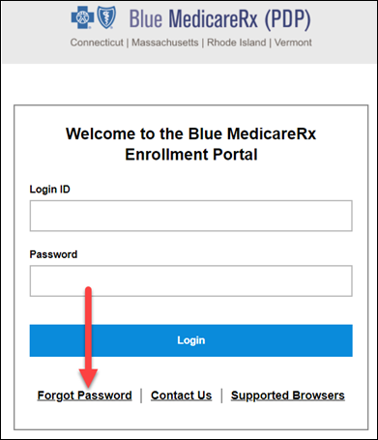  Result: The Login screen displays.
2 | Enter the Login ID and Password.  Note: The first time the CCR logs in to the Enrollment Portal, s/he will be prompted to create a New Password and select a Security Question and Answer.  If the CCR:  - Has forgotten his/her Login ID, s/he should notify Dedicated Trainer by emailing Kenneth.Bingemer@cvshealth.com to request Login ID.  - Needs to reset his/her Enrollment Portal password, refer to the Forgot Password (CCRs) section of this document.  Resolution Time: 8-12 hours

Top of the Document

Enrollment Portal Basics

Perform the following:
1 | Select the appropriate year (when available). Screenshot to show 2023/2024.  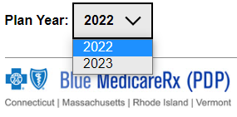  Result: The Home Page will display.
2 | Scan the News, Good to Know, Formulary Update, and Newsletters boxes for important announcements. Screenshot to show 2023/2024.  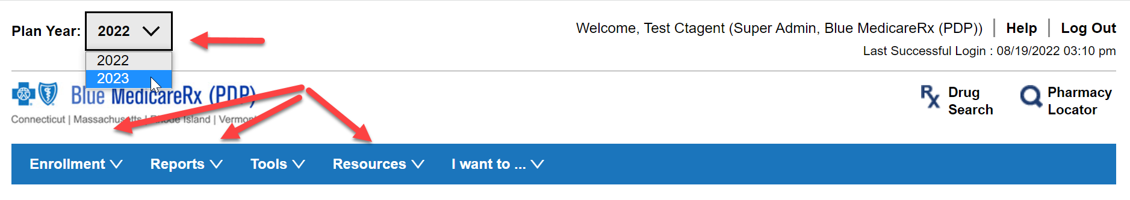  Home Page Details:  - Enrollment - This tab will take you to the Enrollment where CCR can start a new enrollment or search for an enrollment.  - Reports - This tab is to be used to search for completed enrollments  - Resources - CCR will use this tab for easy access to NEJE Website, Plan Offerings, Pre-Enrollment Material Requests (to request plan materials be mailed to prospective beneficiary).  - Drug Search – Link to MED D Blue MedicareRx (NEJE) – Drug Search.  - Pharmacy Locator – Link to inform beneficiaries of preferred and/or standard pharmacies in Network.
3 | Select Pre-Enrollment Material Request under the Resources tab to request plan materials for the potential beneficiary.  Example: A potential beneficiary requests for material to be mailed. CCR will need to complete all Mandatory Fields and select items requested. NEJE will send the comprehensive formulary.  Items included for Individual members are: Prospect Letter, Sales Brochure, Summary of Benefits, Top 100 Drug List, Network Chain Pharmacy List, Privacy Notice, Enrollment Form, Plan Rating Sheet, Multi-language Insert (MLI), and a Business Reply Envelope for the Enrollment Form  Items included for EGWP members are: Summary of Benefits, Top 100 Drug List, Network Chain Pharmacy List, Privacy Notice, Enrollment Form (only for CT and RI), and Multi-language Insert (MLI)  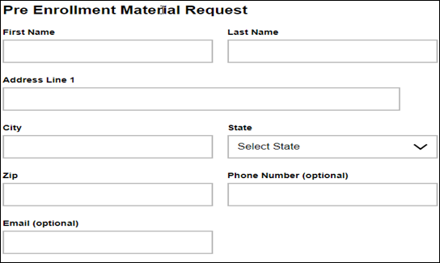  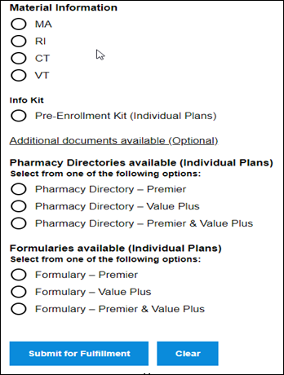
4 | Select Enrollment Search under the Reports tab to locate a completed enrollment with MBI or Confirmation number.
5 | Select Phone Enrollment under the Enrollment tab to start the enrollment process with the perspective beneficiary.  Refer to the Completing a Phone Enrollment Application.

Top of the Document

Forgot Password (CCRs)
If a CCR forgets their Password, they should perform the following steps:

Note: Portal will lock after 3 failed attempts.
Step | Action
1 | Access the Enrollment Portal at https://enrollmentportals.com/Auth/Login.aspx?insCo=neje.  Result: The Login screen displays
2 | Select Forgot Password.
3 | Enter the Login ID and select Continue.  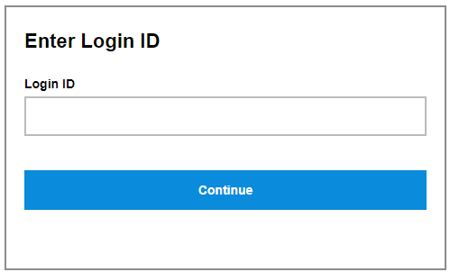  Result: A screen providing additional instructions on how to reset the CCR’s password will display with the following message:  - If a valid username is entered, you will receive an email within the next 30 minutes with further instructions on changing your password.  - If you do not receive an email, you may have mistyped your username or you do not have a valid email address on your profile. Contact the Dedicated Trainer by emailing Kenneth.Bingemer@cvshealth.com for further assistance with changing your password.
4 | Determine if an email was received to change the Enrollment Portal password.
4 | If an email was… | Then…
4 | Received | Email will be received from information@neje.com.  Proceed to Step 5.
4 | NOT received | Email Kenneth.Bingemer@cvshealth.com to reset the password.  The email should include:  Subject: NEJE Portal Password Reset  Body of Message: Please reset the password for <CCR's First and Last Name>.  - Include the Enrollment Portal Login ID and site location.  Resolution Time: 8 to 12 hours
5 | Click the hyperlink provided in the email.  Result: The Change user password screen displays.
6 | Enter the following information:  - Old Password: Enter the temporary password sent in the email.  - New password: Type the new password.  - Password must:  - Have a minimum of 8 characters  - Contain at least 1 alpha-character  - Contain at least 1 number  - NOT repeat a character 3 times in a row  - Confirm new password: Re-type the new password.  - Your Security Questions: Select a Security Question.  - Your Answer: Enter the answer to the Security Question.
7 | Select Save.  Result: The portal will indicate the password has been successfully changed.
8 | Select Log Out.  Result: Login screen appears.

Top of the Document

Completing a Phone Enrollment Application
CCR should open the MED D - Enrollment NotePad Template from his/her local drive to record Medicare information about the beneficiary for use throughout the application.

Once the enrollee has chosen a Blue MedicareRx (NEJE) plan and s/he is ready to enroll, the CCR will:
- Access the enrollment portal.
- Confirm the beneficiary has a valid election period. Review MED D - Election Periods for Enrollment and Disenrollment (AEP, IEP, SEP)

Perform the following:
Step | Action
1 | Thank you for calling Blue MedicareRx, a Medicare approved prescription drug plan. My name is _____________ how may I help you?  OR  Thank you for calling Customer Care, my name is _____________ how may I help you?  CCR Process Note: All phone enrollment calls are warm transferred from a sales agent.
2 | - Authenticate the caller (Do not assume it is a non-member).  - If no eligibility information is available, authentication is not required.  - Refer to:  - Caller Authentication and HIPAA Grid – CVS  - Caller Authentication (Non IVR Authenticated call)
3 | I am happy to personally enroll you today in Blue MedicareRx (NEJE). Medicare requires that we record all enrollments. May I record this call?
3 | If prospective enrollee says… |  |  | Then…
3 | Yes |  |  | Proceed to next step.
3 | No |  |  | Notify the prospective enrollee that they may enroll via:  - The Blue MedicareRx (PDP) Website www.rxmedicareplans.com by printing out a paper enrollment form and mailing or faxing it in when completed.  - Visit www.Medicare.gov - Plan Finder to enroll in Blue MedicareRx.
4 | I would like to confirm that you do want to enroll in the (1 or 2) _____ plan, which has a monthly premium of (<$_______>).  1 - Blue MedicareRx Value 2 - Blue MedicareRx Value  Plus Prescription Drug Plan Premier Prescription Drug Plan  (<$53.40>) (<$155.80>)  CCR Process Note: Confirm Effective Date: Ask the beneficiary when they would like the plan to start.
5 | Determine who is calling.  Are you the enrollee or are you authorized to act on behalf of the prospective enrollee?  Note: If caller is the applicant’s authorized representative, please be sure to clarify that the questions asked are specific to the enrollee.  CCR Process Note: If the beneficiary has problems hearing on the phone and wants someone else to give all enrollment information, that is permissible as long as the beneficiary first comes to the phone and provides consent. In those circumstances, the person who is helping the beneficiary on the phone is NOT the authorized representative; remind caller that the beneficiary will need to return to the phone at the end of the call to agree to the final verbal attestation for the plan to submit the enrollment application.
5 | If caller is… | Then…
5 | Authorized representative assisting with the telephone enrollment | As the authorized representative, are you authorized under State law to complete the enrollment and is documentation of this authority available upon request?
5 | NOT an authorized representative | Let the caller know that only authorized representatives can complete an enrollment for a prospective enrollee.  Is the enrollee aware you are calling on their behalf?
5 | NOT an authorized representative | If… | Then…
5 | NOT an authorized representative | Yes | Obtain the data below.  - May I please have your name and how you spell?  - May I please have your date of birth and gender?  - May I please have your telephone number, area code first?  - May I please have your permanent address? (P.O. Box not allowed) Also ask for email address at this point.  - Is your mailing address the same as your permanent address?  - Are you a resident in a long-term care facility, such as a nursing home? If yes, need name/address/phone number of the facility.
5 | NOT an authorized representative | No | Please let the caller know that we may not enroll a prospective enrollee without their knowledge and consent.
6 | May I please have your Federal Medicare ID number/Claim number as it appears on the red/white/blue Federal Medicare card?  CCR Process Note:  - Look up number in MARx to verify accuracy and confirm Medicare Part A and Medicare Part B effective dates. Review MED D - Verifying Enrollment, Eligibility and LIS in MARx.  - If the beneficiary is previously reflecting in Plan S2893, review PeopleSafe Medicare D Inquiry tab to determine previous election period and if the beneficiary has a past due balance.
7 | Are you currently enrolled with or are you entitled to Medicare Part A?
7 | If… |  | Then…
7 | Yes |  | What is the Medicare Part A effective date that appears on your Medicare Card?  Proceed to next step.
7 | No |  | Proceed to next step (Medicare Part B).
8 | Are you currently enrolled with or are you entitled to Medicare Part B?
8 | If… |  | Then…
8 | Yes |  | What is the Medicare Part B effective date that appears on your Medicare Card?  Proceed to next step.
8 | No |  | Unfortunately, this coverage is only available to individuals who are entitled to Medicare Benefits.  Proceed to end call.
9 | Will you have other prescription drug coverage in addition to Blue MedicareRx?
9 | If… |  | Then…
9 | Yes |  | Please list your other coverage and your identification (ID) number(s) for this coverage:  - Name of other coverage  - ID # for this coverage  - Group # for this coverage
9 | No |  | Proceed to next step.
10 | Coordination of Benefits Addendum  Are you a member of a Medicare Advantage Plan (like an HMO or PPO)?
10 | If… |  | Then…
10 | Yes |  | - You may already have prescription drug coverage from your Medicare Advantage Plan that will meet your needs.  - By joining Blue MedicareRx (NEJE), your membership in your Medicare Advantage Plan will end.  - This will affect both your doctor and hospital coverage as well as your prescription drug coverage.  - Read the information that your Medicare Advantage Plan sends you and if you have questions, contact your Medicare Advantage Plan.  Proceed to next step.
10 | No |  | Proceed to next step.
11 | Do you currently have health coverage from an employer or union?
11 | If… |  | Then…
11 | Yes |  | - Joining Blue MedicareRx (NEJE) could affect your employer or union health benefits.  - You could lose your employer or union health coverage if you join Blue MedicareRx (NEJE).  - Read the communications your employer or union sends you.  - If you have questions, visit their website, or contact the office listed in their communications.  - If there is not information on whom to contact; your benefits administrator or the office that answers questions about your coverage can help.  Proceed to next step.
11 | No |  | Proceed to next step.
12 | - Typically, you may enroll in a Medicare Prescription Drug Plan only during the annual enrollment period between October 15 and December 7 of each year.  - Are you applying during the Annual Enrollment Period for an effective date of January 1?
12 | If… |  | Then…
12 | Yes |  | Check off Annual Enrollment Period box.  - I am applying during the Annual Enrollment period (October 15 through December 7) for an effective date of January 1.
12 | No |  | Or if today’s date is December 8th through October 14th:  - There are exceptions that may allow you to enroll in a Medicare Prescription Drug Plan outside of the annual enrollment period.  - Please listen carefully to following statements and let me know if one of the statements applies to you. By telling me that one of the following statements applies, you are certifying that, to the best of your knowledge, you are eligible for a Special Enrollment Period.  - If we later determine that this information is incorrect, you may be disenrolled.  CCR Process Note: CCR should see available Reason Codes for IEP and SEP.
12 |  |  | If... |  | Then...
12 |  |  | Enrollment period is SEP 222 - SEPs for Exceptional Conditions (Sections 30.3.3, 30.3.7, and 30.3.8) for new beneficiaries. |  | Confirm the application date and effective date auto-populated.  Proceed to next step.
12 |  |  | Enrollment period is SEP 222 - SEPs for Exceptional Conditions (Sections 30.3.3, 30.3.7, and 30.3.8) for existing plan beneficiaries with no gap in coverage requesting a PBP change. |  | Note: An RM Task should be submitted for review of beneficiary’s allegations against the plan.  Unfortunately, I will not be able to take an enrollment for <you, enrollee’s name> in Blue Medicare Rx at this time. Further research is required. I will submit your request to the appropriate department to research.  Refer to MED D - SilverScript and Blue MedicareRx (NEJE) - Enrollment Related RM Tasks.  CCR Process Note: Submit RM Task and answer questions as applicable.
12 | CCR Process Note: If beneficiary does not have any valid election period, then:  Unfortunately, [you / name of the beneficiary] are/is not eligible to join Blue MedicareRx (NEJE) as there is no valid election period available. I will not be able to take an enrollment for [you / name of Medicare beneficiary] in Blue MedicareRx (NEJE) at this time.
13 | - You have the option of receiving plan materials in large print.  - Would you prefer to receive your plan materials in large print?
13 | If… |  |  | Then…
13 | Yes |  |  | Refer to Med D - Fulfillment Request work instructions.  Proceed to next step.
13 | No |  |  | Proceed to next step.
14 | - Do you work?  - Does your Spouse work?  Note: The questions above are required to be asked but are optional for the beneficiary to respond.  Proceed to Premium Payment Options.

Top of the Document

Premium Payment Options

Perform the following:
Step | Action
1 | - The Blue MedicareRx plan has a monthly premium of (<$____ >).  CCR Process Note: See State Rate Table.  - You have the option of either having your monthly premium deducted from your Social Security/Railroad Retirement Board check or to have your premium direct billed to you.  - In order to complete your enrollment, you must select a payment option.  - May I ask which option works best for you?
1 | If beneficiary chooses to… | Then…
1 | Receive a bill in the mail that you will pay by check, money order or debit/credit card. | CCR Process Note: If direct bill option is selected, proceed to Extra Help paragraph (next step).
1 | Automatically deduct the premium from your Social Security benefit check | - Your monthly plan premium deduction may take up to 90 days to begin and will not cover any premiums for which we have already sent you an invoice.  - Therefore, until your automatic deduction is approved, we will continue to send you a paper bill each month.  - Please continue to pay your premium invoice for as long as you receive it.  - In most cases, if Social Security/ Railroad Retirement Board accept your request for automatic deduction, the first deduction from your Social Security/Railroad Retirement Board benefit might not include all premiums owed from your enrollment effective date up to the point withholding begins.  - If you owe any premiums retroactive to the date of the Social Security/Railroad Retirement Board deductions, we will send you a paper bill for those premiums.  - If Social Security/ Railroad Retirement Board do not approve your request for automatic deductions, we will send you a paper bill for your monthly premiums.
1 | Automatically deduct the premium from your Railroad Retirement Board benefit check | - Your monthly plan premium deduction may take up to 90 days to begin and will not cover any premiums for which we have already sent you an invoice.  - Therefore, until your automatic deduction is approved, we will continue to send you a paper bill each month.  - Please continue to pay your premium invoice for as long as you receive it.  - In most cases, if Social Security/ Railroad Retirement Board accept your request for automatic deduction, the first deduction from your Social Security/Railroad Retirement Board benefit might not include all premiums owed from your enrollment effective date up to the point withholding begins.  - If you owe any premiums retroactive to the date of the Social Security/Railroad Retirement Board deductions, we will send you a paper bill for those premiums.  - If Social Security/ Railroad Retirement Board do not approve your request for automatic deductions, we will send you a paper bill for your monthly premiums.
2 | Extra Help  - People with limited incomes may qualify for extra help to pay for their prescription drug costs. If you qualify, Medicare could pay up to 75% or more of your drug costs including monthly prescription drug premiums, annual deductibles, and co-insurance. Additionally, those who qualify won't have a coverage gap or a late enrollment penalty. Many people are eligible for these savings and don't even know it. For more information about this extra help, call:  - Your local Social Security office or call Social Security at 1-800-772-1213 between 8:00 a.m. and 7:00 p.m. Local Time, Monday through Friday.  - TTY users should call 1-800-325-0778.  - You (or your authorized representative) can also apply for extra help online at www.socialsecurity.gov/prescriptionhelp  - 1-800-MEDICARE (1-800-633-4227), 24 hours a day, 7 days a week.  - TTY users should call 1-877-486-2048  - Your local Medicaid Office  If you are assessed a Part D-Income Related Monthly Adjustment Amount, you will be notified by the Social Security Administration. You will be responsible for paying this extra amount in addition to your plan premium. You will either have the amount withheld from your Social Security or Railroad Retirement Board benefits check or be billed directly by Medicare. Do NOT pay the Part D-IRMAA extra amount to Blue MedicareRx.  If beneficiary is showing a past due balance, say the following:  - I need to advise you that our system shows that you have a previous unpaid balance with <Plan Name> in the amount of <amount>.  - We will send you written notification of your unpaid balance. Your Enrollment will be considered incomplete for 21-days from the date listed on that notification or until the end of the month (whichever is later). Once the payment is received; your application will be submitted to Medicare for processing. If the payment is not made your enrollment will be denied.  Note: If the beneficiary indicates that they would like to make a payment, provide the beneficiary with the number to the Customer Care Department and offer to transfer the beneficiary upon completion of the enrollment application.)  The Customer Care department is open for phone calls 24 hours a day, 7 days a week. The phone number is:  BCBS of CT:1-888-620-1747TTY/TDD: 711  BCBS of MA:1-888-543-4917TTY/TDD: 711  BCBS of RI:1-888-620-1748TTY/TDD: 711  BCBS of VT:1-888-620-1746TTY/TDD: 711  In the Notes Box (limit 300 characters), enter the following:  - Reason for enrollment (enrollment period and date)  - MARx verified or reason why not verified  - Name of person assisting enrollee  - Other important details  Proceed to Enrollment Acknowledgement.

Top of the Document

Enrollment Acknowledgement

Perform the following:
Step | Action
1 | Enrollment Acknowledgement  CCR Process Note: The Agent MUST Read This Important Information  Medicare requires a clear Yes or No response to each of the following statements.  By completing this telephone enrollment, you (or your authorized representative) acknowledge and agree to the following:  Blue MedicareRx is a Medicare drug plan and has a contract with the Federal government. You understand that this prescription drug coverage is in addition to your coverage under Medicare; therefore, you will need to keep your Medicare Part A or Part B coverage. It is your responsibility to inform Blue MedicareRx of any prescription drug coverage that you have or may get in the future. You can only be in one Medicare prescription drug plan at a time - if you are currently in a Medicare Prescription Drug Plan, your enrollment in Blue MedicareRx will end that enrollment.  YES NO  Enrollment in this plan is generally for the entire year. Once you enroll, you may leave this plan or make changes if an enrollment period is available, generally during the Annual Enrollment Period < (October 15th - December 7th)>, unless you qualify for certain special circumstances.  YES NO  Blue MedicareRx serves a specific service area. If you move out of the area that Blue MedicareRx serves, you need to notify the plan so you can disenroll and find a new plan in your new area. You understand that you must use network pharmacies except in an emergency when you cannot reasonably use Blue MedicareRx network pharmacies. Once you are a member of Blue MedicareRx, you have the right to appeal plan decisions about payment or services if you disagree. You will read the Evidence of Coverage document from Blue MedicareRx when you get it to know which rules you must follow to get coverage.  YES NO  You understand that if you leave this plan and don’t have or get other Medicare prescription drug coverage or creditable prescription drug coverage (as good as Medicare’s), you may have to pay a late enrollment penalty in addition to your premium for Medicare prescription drug coverage in the future.  YES NO  You understand that if you are getting assistance from a sales agent, broker, or other individual employed by or contracted with Blue MedicareRx, he/she may be paid based on your enrollment in Blue MedicareRx.  YES NO  Counseling services may be available in your state to provide advice concerning Medicare supplement insurance or other Medicare Advantage or Prescription Drug Plan options, medical assistance through the state Medicaid program, and the Medicare Savings Program  Release of Information: By joining this Medicare prescription drug plan, you acknowledge that Blue MedicareRx will release your information to Medicare and other plans as is necessary for treatment, payment and health care operations. You also acknowledge that Blue MedicareRx will release your information, including your prescription drug event data, to Medicare, who may release it for research and other purposes which follow all applicable Federal statutes and regulations. The information on this enrollment is correct to the best of your knowledge. You understand that if you intentionally provide false information, you will be disenrolled from the plan.  YES NO  You understand that your verbal agreement (or the verbal agreement of the person authorized to act on your behalf under State law where you live) on this application means that you (or your authorized representative) have heard and understand the contents of this application. If agreed to by an authorized individual (as described above), you certify that: 1) you are authorized under State law to complete this enrollment and 2) documentation of this authority is available upon request by Blue MedicareRx or by Medicare.  YES NO  Do you wish to proceed with submitting this application to Medicare?
1 | If… | Then…
1 | Yes | Continue to next step.
1 | No | - Okay, since you have stated that you do not want me to submit your application to Medicare, I will not need to capture any additional information.  - Thank you for your time.  - Is there anything else I can help you with today?
2 | Confirm the Enrollment Details Below  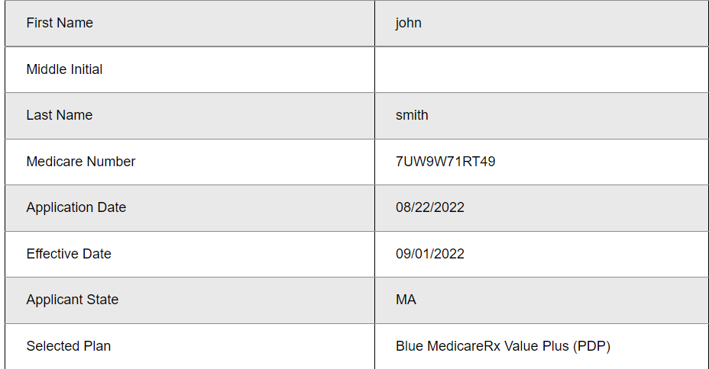  Say and spell everything entered back to the enrollee to ensure information is correct (This is important to avoid delays).
3 | Phone Enrollment Close  Thank you for providing that information. Your phone enrollment in the Blue MedicareRx Plan is now complete.
3 | If… | Then…
3 | IEP or SEP enrollment period | - Pending Medicare approval, your coverage will begin on <MONTH/DD/YYYY>.  CCR Process Note: Effective date: First of the following month of application.  - You will receive an application status letter within 10 calendar days.  Proceed to next step.
3 | AEP enrollment period <(October 15th - December 7th)> | - Pending Medicare approval, your coverage will begin on January 1, <2024>.  - You will receive an application status letter within 10 calendar days.  Proceed to next step.
4 | Enrollment Verification  - I would also like to advise you that you will be receiving a letter in the mail confirming your enrollment into the Blue MedicareRx Plan.  - The purpose of this letter is to ensure you understand the rules of the plan, before your enrollment into the plan becomes final.  - Upon approval of your application from Medicare, Blue MedicareRx will mail you a plan welcome kit.  - Included in your kit will be your member ID card.  - This card will contain all the necessary information your pharmacist needs to fill your prescriptions.  - You will also need information from this card to request a prescription fill from the mail service pharmacy.  - Is there anything else I can help you with today?  - For additional information regarding your Blue MedicareRx plan you can go to www.RxMedicarePlans.com or call Customer Care at:  - BCBS of CT: 1-888-620-1747 - TTY/TDD: 711  - BCBS of MA: 1-888-543-4917 - TTY/TDD: 711  - BCBS of RI: 1-888-620-1748 - TTY/TDD: 711  - BCBS of VT: 1-888-620-1746 - TTY/TDD: 711
5 | Confirmation Number  I would like to offer you a confirmation number ____________. This number will be used to confirm your enrollment.

Top of the Document

Completing Enrollment Applications Offline

If the Blue MedicareRx Agent Portal is offline (CCR will be notified via email or Teams), the CCR can still accept enrollment applications by performing the following steps:
Step | Action
1 | - MED D Customer Care Representative (CCR) will fill out the hard copy of the enrollment (on-site) or access the electronic version of enrollment form.  - Review completed Enrollment Information with caller and edit where necessary.
2 | - A Blue MedicareRx plan representative will process your enrollment application.  - You’ll receive a letter acknowledging receipt of your application for enrollment in Blue MedicareRx within <10> calendar days.  - We will send your application to the Medicare for approval.  - If Medicare approves your application, Blue MedicareRx will notify you that your enrollment in the Blue MedicareRx plan you selected is confirmed.  - If Medicare does not approve your application, Blue MedicareRx will send you a notice of denial and an explanation.  - If your enrollment is approved, Blue MedicareRx will mail your Prescription Drug Plan Member ID card within <14> days of your effective enrollment date.  - If your enrollment is approved, you may begin using your Blue MedicareRx prescription drug plan benefits beginning on your effective enrollment date.
3 | - <Caller name>, I’d like to thank you once again for contacting Blue MedicareRx.  - Please remember that you can visit us online 24 hours a day, 7 days a week, at www.rxmedicareplans.com.  - You can also call us back at toll-free, 24 hours a day, 7 days a week at  - MA: 888-543-4917  - CT: 888-620-1747  - VT: 888-620-1746  - RI: 888-620-1748  - TTY users call 711.  - If you have no other questions today, I’d like to thank you once again for calling Blue MedicareRx.  - Have a wonderful day!

Top of the Document

Completed Enrollment Process Offline

Perform the following if WFH MED D Customer Care Representative (CCR):
Step | Action
1 | Immediately after saving the enrollment to desktop, the WFH MED D Customer Care Representative (CCR) will email the enrollment to Kenneth.Bingemer@cvshealth.com and supervisor.  - Subject Line:  - **SECUREMAIL**  - Manual Enrollment - < NEJE>  - Enrollee’s Last Name  - Date/Time stamp of the call  - Body of email:  - Enrollee’s MBI (including alpha character)  - Attach completed saved enrollment
2 | Designated MED D Customer Care Representative (CCR) will enter into the agent portal when portal is back online.
3 | Another designated MED D Customer Care Representative (CCR) or Supervisor will complete a quality check before it is submitted.  Note: If the portal is down for more than 2 hours, designated MED D Customer Care Representative (CCR) will scan completed enrollment and email NEJEEnrollmentSupport@cvscaremark.com; Cc Kenneth.Bingemer@cvshealth.com and supervisor.  - Subject Line:  - **SECUREMAIL**  - Manual Enrollment - < NEJE>  - Enrollee’s Last Name  - Date/Time stamp of the call  - Body of email:  - Enrollee’s MBI (including alpha character)  - Attach all scanned completed enrollments

Top of the Document

Completing Enrollment Applications Offline FAQs

Use as needed:
Question | Answer
I would like a confirmation number for my enrollment; can you provide me with one? | - I am not able to provide a confirmation number at this time.  - You can call back in the next 24-48 hours. A MED D Customer Care Representative (CCR) will be able to provide your confirmation number to you.  - You will need to provide your Member Beneficiary Identifier (MBI) so we can access your enrollment.
How will I know that my enrollment has been accepted? | - You’ll receive a letter acknowledging receipt of your application for enrollment in Blue MedicareRx within <10> calendar days.  - If Medicare approves your application, Blue MedicareRx will notify you that your enrollment in the Blue MedicareRx plan you selected is confirmed.  - If Medicare does not approve your application, Blue MedicareRx will send you a notice of denial and an explanation.  - If your enrollment is approved, Blue MedicareRx will mail your Prescription Drug Plan Member ID card within <14> days of your effective enrollment date.  - If your enrollment is approved, you may begin using your Blue MedicareRx prescription drug plan benefits beginning on your effective enrollment date.

Top of the Document

Resolution Time
In order for CVS Caremark Part D Services, L.L.C. to meet the required timeframes every completed Enrollment must be processed within 4 days.
- To ensure compliance, each completed Enrollment is to be processed within 72 hours or 3 calendar days.
- Beneficiary materials are provided no later than 10 calendar days after the receipt of the completed application form.

CVS Caremark Part D Services, L.L.C. must submit the information necessary for CMS to add the Enrollee to its records as an enrollee of CVS Caremark Part D Services, L.L.C. within 7 calendar days of receipt of the completed Enrollment request.
- A notice acknowledging receipt of the Enrollment request providing the expected effective date of enrollment is sent to the enrollee no later than 10 calendar days after receipt of the completed Enrollment request.

Top of the Document

Related Documents
- MED D - SilverScript and Blue MedicareRx (NEJE) - Enrollment Related RM Tasks
- MED D Blue MedicareRx (NEJE) – Drug Search

Parent SOP: CALL-0048: Medicare Part D Customer Care Call Center Requirements-CVS Caremark Part D Services, L.L.C.
Abbreviations/Definitions: Abbreviations / Definitions
Top of the Document

Not to Be Reproduced or Disclosed to Others without Prior Written Approval
ELECTRONIC DATA = OFFICIAL VERSION - PAPER COPY = INFORMATIONAL ONLY

